Successive Odor Matching- and Non-Matching-to-Sample in Rats: A Reversal Design

Katherine Bruce, Katherine Dyer, Michael Mathews, Catherine Nealley, Tiffany Phasukkan, Ashley Prichard & Mark Galizio

University of North Carolina Wilmington

Author Note

The authors would like to thank Samantha Hess, Erin Lackey, Danielle Panoz-Brown, and Alyssa Crawley assisted in data collection. Ashley Prichard is now at Department of Psychology, Emory University. Correspondence concerning this article should be addressed to Katherine Bruce, Department of Psychology, UNCW, 601 S. College Rd., Wilmington, NC, 28403. Email: [bruce@uncw.edu](mailto:bruce@uncw.edu).

Abstract

There is a growing body of research on matching- and non-matching-to-sample (MTS, NMTS) relations with rats using olfactory stimuli; however, the specific characteristics of this relational control are unclear. In the current study we examine MTS and NMTS in rats with an automated olfactometer. Ten rats were trained to either match or non-match to sample in an olfactometer with common scents (apple, cinnamon, etc.) as olfactory stimuli. After matching or non-matching training with four exemplars, rats were tested for transfer twice with four new odorants each time. Most rats trained on MTS showed immediate transfer to new stimuli, and most rats trained on NMTS showed full transfer by the second set of new odors. After meeting criterion on the second transfer, the contingencies were reversed with four new odor stimuli such that subjects trained on matching were shifted to non-matching and vice versa. Following these reversed contingencies, the effects of the original training persisted for many trials with new exemplars. These data extend previous studies on identity and oddity concept formation in rats, showing strong generalization requiring few exemplars. The critical role of olfactory stimuli is discussed.

Keywords: olfaction; matching-to-sample; identity; oddity; reversal learning; rats; abstract concepts

As identity and oddity are two of the most elemental concepts, they have been the focus of most recent research on concept learning in nonhumans. Identity and oddity can be operationalized by same/different or match/non-match to sample (MTS/NMTS) procedures, such that successful transfer to novel stimuli defines the emergence of concept learning. Using such procedures, identity/oddity has been demonstrated in a number of species, including primates (D'Amato, Salmon & Colombo, 1985; Katz, Wright, & Bachevalier, 2002; Vonk, 2003), dolphins (Herman, Hovancik, Gory, & Bradshaw, 1989), sea lions (Kastak & Schusterman, 1994), pigeons and other birds (Bodily, Katz & Wright, 2008; Magnotti, Katz, Wright, & Kelly, 2015; Wright, Cook, Rivera, Sands, & Delius, 1988), echidna (Russell & Burke, 2016) and honeybees (Giurfa, Zhang, Jenett, Menzel, & Srinivasan, 2001). Initial studies with rodents using visual stimuli (e.g., Iversen, 1993; 1997) failed to show identity/oddity but with the use of olfactory stimuli, there has been more success (e.g., April, Bruce & Galizio, 2011; Peña, Pitts, & Galizio, 2006; Prichard, Panoz-Brown, Bruce & Galizio, 2015).

Using an olfactory discrimination procedure, Peña, et al. (2006) trained rats to dig in scented sand to obtain sucrose pellets (cf. Dusek & Eichenbaum, 1997) and found evidence for generalized matching-to-sample. Rats were initially trained on a single conditional discrimination (two olfactory stimuli) and novel stimuli were added as criterion level performances were reached. At the end of the study, rats were matching at high levels of accuracy with 20 or more different stimuli and responses to novel stimuli were well above chance levels in three of the four rats tested. However, as novel stimuli were only introduced one or two at a time, it was not possible to identify precisely at what point generalized matching developed.

To examine this, April, et al. (2011) used the same olfactory discrimination procedure to train six rats on either MTS or NMTS. In this study, a reversal procedure based on the Zentall and Hogan (1974) study with pigeons was used such that after initial MTS or NMTS training, contingencies were switched and transfer assessed. Zentall and Hogan inferred concept learning from response persistence to the originally trained contingency. April et al. trained rats on either MTS or NMTS with five scent stimuli (set A); once rats responded with 90% accuracy, they were switched to five new stimuli (set B) and showed evidence of savings in these transfer tests. After 15 sessions with these stimuli (set B), a new stimulus set of five odors (set C) was presented with the previous contingencies reversed. Initial levels of accuracy were quite low as all animals continued to respond in line with the original MTS or NMTS contingency from sets A and B. Even after extended training, most animals failed to exceed chance levels of responding on the new contingency with set C. This study showed that rats developed the identity or oddity relation with as few as 10 exemplars.

The studies noted above used scented sand to present the odorants and a manual procedure with simultaneous conditional discrimination training. In order to increase experimental control, Prichard, et al. (2015) used an automated olfactometer to present odors. Six rats were trained on a go-no go MTS procedure with four odor stimuli. Stimuli were presented in pairs and nose-poke responses to matching odor pairs, but not non-matching pairs, were reinforced. Once rats met criterion responding, non-reinforced probe trials with novel odors were intermittently introduced. Most rats showed high levels of transfer, suggesting that four exemplars may be sufficient for emergence of the identity relation. This outcome was surprising as most studies have found that many more trained exemplars are necessary to produce good transfer in other species (Wright, Magnotti, Katz, Leonard, & Kelly, 2016).

In the current study, using an automated olfactometer to present odor stimuli, we replicate and extend Prichard, et al. (2015) to compare acquisition of both identity and oddity relations. Further, we employ a reversal design, similar to April, et al. (2011) and Zentall and Hogan (1974), to examine transfer across stimuli and persistence of the original contingencies to infer concept learning.

**Method**

**Subjects**

The subjects of this experiment were 15 male Sprague-Dawley albino rats approximately 90-150 days old at the beginning of training. All rats were individually housed on a reversed 12 hour light-dark cycle. The rats were maintained at 85 percent of their free feeding weight and received ad *libitum* access to water in their home cages. All experiments were performed during the dark phase, between 7:00 a.m. and 6:00 p.m. Rats were fed Lab Diet Rat Chow daily approximately 1 hr following their individual experimental session.

**Apparatus**

Sessions were conducted in Med Associates operant chambers with three response ports located across the front panel; however, only the center port was activated during the experiment. Inside the center port was a stimulus light, infrared photo beam response detector, and openings for scents to be pumped in and drawn out. The chamber measured 30.5 cm long by 24 cm wide by 21 cm high with a pellet dispenser located on the opposite side of the chamber from the response ports. Chambers were housed in sound attenuating cubicles. Each chamber was interfaced to a computer equipped with MED-PC software. Three five-channel Med Associates olfactometer systems (ENV-275-5) were added to each chamber. An input pump (Linear AC0102, 2.84 pound per square inch with an airflow of .177 cubic feet per min) delivered air through glass jars containing an odorant solution to solenoids that, when operated, forced scented air through Teflon tubing and a manifold into the center nose port of the chamber. A vacuum pump (Linear VP0125, -9.84 Hg vacuum and air displacement of .247 cubic feet/min) removed air from a tube located at the bottom of the center port. Thus, the system was capable of delivering 15 separate odors through the center response port (see Prichard, et al. 2015 for an illustration.)

**Odorants**

Liquid odorants purchased from The Great American Spice Company. Nature’s Garden, and local stores were used to create four sets of stimuli: Set A (cinnamon, apricot, bubblegum, root beer) and Set B (brandy, vanilla butternut, almond, and licorice), Set C (apple, grass, coconut, sandalwood), Set D (clove, honey, blueberry, geraniol). A fifth set (E: lemon, maple, lavender, and peppermint) was used with one rat but the peppermint oil appeared to contaminate the apparatus and disrupt performance, so these scents were discontinued). Odorants were diluted to a solution of 6.7 ml oil per 100 ml distilled water. Glassware was cleaned at the end of each testing day and solutions were refilled every morning.

**Procedure**

**Shaping Phase.** An initial session of magazine training was followed by response training in which both the center port light and house light were illuminated. During this phase, a single nose-poke turned off both lights, and delivered a sugar pellet accompanied by a light above the food hopper. After a 5-s period, the hopper light went out and the house and center-port lights came on and the procedure continued to provide FR1 reinforcement. Once regular responding was established, the reinforcement schedule was progressively increased to FI-5s over several sessions. To acclimate animals to scent delivery through the center port, four odorants were introduced for each rat (see Table 1). Each trial began with the onset of the house light and center port light and delivery of one of the four odorants; completion of the FI-5s schedule terminated the lights and odorant delivery and produced reinforcement and the onset of the hopper light for 5 s.

**Initial Conditional Discrimination Training Phase.** Once rats were consistently responding to all four scents throughout the session, conditional discrimination training began. Rats were randomly assigned to either MTS or NMTS training and began training with the initial stimulus set used in shaping (see Table 1). All trials consisted of stimulus pairs presented through the center port and only center port responses were effective throughout the experiment. Trials began with the onset of the house light and center port light. Following an initial observing nose-poke response, a sample odor was presented, with the first nose poke after 5 s (FI-5s schedule) resulting in a 1s termination of the house and center port lights, followed by the onset of the comparison odor and both lights. On positive trials (matching for the MTS group and non-matching for the NMTS group), responding was reinforced on an FI-5s schedule. The first response after 5s resulted in termination of the comparison odor, the house light, and the center port light and a 5s onset of the hopper light along with delivery of a sugar pellet. On negative trials, the comparison was presented for 5s and then terminated, along with the house and center port lights. A 30s inter-trial interval separated the termination of the comparison stimuli and the initiation of the following trial.

Sessions were conducted five days/week. Each session was composed of 48 trials and included eight different trial types, four positive and four negative. For example, for Set A scents, MTS positive/reinforced trial types were cinnamon-cinnamon, apricot-apricot, bubblegum-bubblegum, and rootbeer-rootbeer; negative/unreinforced trial types were cinnamon-bubblegum, apricot-rootbeer, bubblegum-cinnamon, and rootbeer-apricot. For the subjects initially trained on NMTS, Set A positive trial types were cinnamon-bubblegum, apricot-rootbeer, bubblegum-cinnamon, and rootbeer-apricot; negative trial types were cinnamon-cinnamon, apricot-apricot, bubblegum-bubblegum, and rootbeer-rootbeer. Trial types were randomly determined with the constraint that no more than 4 consecutive positive (reinforced) or negative (non-reinforced) trial types were permitted. Initially, training continued until a mastery criterion was met such that an average discrimination ratio (DR: responses to S+ divided by responses to both S+ and S-) of .85 with a minimum DR of .80 on each trial type was met on two consecutive sessions. Although some rats met this criterion, many developed discriminative performances but failed to meet criterion even after extensive training, and the criterion was reduced to a mean DR of .80 on each trial type for two consecutive sessions, which further weakened to .80 for a single session. Despite these changes, five rats failed to meet training criterion after more than 75 sessions of training and were dropped from the study (two in MTS and three in NMTS—four never met criterion on the initial set, and one failed to meet criterion on Set 3).

**Transfer to Novel Odors**. When the prevailing criterion was met, rats were advanced to transfer phase 1 which presented a new set of four odorants (see Table 1) under the same contingencies used in the initial training phase (MTS or NMTS). Training continued on the second set of odors until rats met the mastery criterion as described above. When the criterion was met, rats were advanced to another new set of four odorants with the same contingencies (transfer phase 2). Once mastery was met on this third set of odors, rats were moved to the Reversal Phase in which four new odorants were presented, but the contingencies were reversed (i.e., MTS animals were reversed to NMTS and vice versa), and these reversal contingencies were maintained for at least 10 sessions.

**Data Analysis.** The primary measure of interest was transfer of matching or non-matching on the initial exposure to novel stimuli in the transfer and reversal phases. This was assessed by comparing response rates on positive and negative trial types during the first session with each novel stimulus set and those obtained during the final (criterion) session of the previous set. In addition, response rates on the initial exposure to each novel trial type during the first session with a new stimulus set were analyzed separately. Finally, DRs obtained during the first few sessions of training to the three training stimulus sets and the final reversal set were compared to assess the effects of the changed contingencies. Other measures of savings (e.g., sessions to criterion) were not evaluated because the changes in mastery criteria that were imposed through the experiment as well as apparatus problems that affected some rat’s performance during training made such analyses difficult to interpret.

**Results**

Figure 1 presents the average discrimination ratio for the 10 rats that completed all phases of the study for the first 10 sessions of initial training, first three sessions for transfer phases 1 and 2 (only three sessions are shown because some rats met criterion that rapidly in transfer task 1 and 2) and the first 10 sessions for the reversal phase. In general, acquisition on matching and non-matching was quite rapid with mean DR above .7 by the 10 sessions of initial training in the NMTS and above .8 in the MTS group. There was considerable variability between subjects and the differences between groups were not significant. A 2-way mixed design ANOVA confirmed the improvement in DR across sessions during acquisition [*F*(9,72)=23.0, *p*<.001], with no main effect of training group (MTS or NMTS) and no interaction of training group and sessions. After meeting criterion with the initial stimulus set, accuracy with new stimuli was high on the first sessions of the transfer phases (second and third panels of Figure 1). For both transfer phases 1 and 2, there were no main effects of sessions or training group and no interaction between sessions and training group (all *p*s>.05). Finally, note that when contingencies were reversed, DRs declined to below .5 with a gradual adjustment to the changed contingencies during the following 10 sessions. In the reversal phase, ANOVA confirmed the significant improvement in DR across sessions [*F*(9,72)=19.7, *p*<.001], with no main effect of training group or interaction of training group and sessions.

Although the highly accurate performances on the transfer phases with novel stimuli suggest that rats may have developed generalized MTS/NMTS, it is possible that the high DRs developed due to rapid learning during the initial session. Figure 2 presents an analysis of DRs based only on the initial exposure to each novel trial type during the first session of the transfer phases. DRs were above .5 in both groups on both transfer tasks, providing evidence that the same/different relation transferred to novel stimuli. Rats trained on MTS showed strong evidence of generalized matching on both transfer phases; indeed transfer DRs were similar to those obtained during baseline. However, rats trained on NMTS showed less complete transfer to new stimuli in the first transfer phase, but showed stronger transfer on the second. The reversal resulted in a dramatic drop in accuracy on the first day of reversed contingencies in both groups. Using a 2-way mixed design ANOVA to compare the DR of initial training at criterion to the DR on the first exposure to new scents in transfer phase 1, the first exposure to new scents on transfer phase 2, and the first exposure to new scents with reversed contingencies, we found a main effect of phase [*F*(3,24)=62.7, *p*<.001), no main effect of training group [MTS or NMTS; *F*(1,8) < 1] and a trend for the interaction [*F*(3,24)=2.61, *p*=.074]. Post-hoc comparisons indicated that baseline DR with the initial training set was significantly higher than performance on the first presentation of new scents in transfer 1 (*p*<.01, Tukey’s HSD), but equal to performance on the first presentation of new scents in the second transfer. There was no significant difference in DRs across the two transfer tasks. As expected, reversal DRs were significantly lower than DRs during baselines and both transfer tasks.

The trend in the interaction underscores the variability in DRs, especially for the NMTS subjects at transfer phase 1. Individual subject data highlight the strong transfer for the MTS group and the weaker transfer for the NMTS group. In the individual subject analyses presented in Figures 3 and 4, response rates on positive and negative trials (the basis of the DR measure) are compared directly.

Figure 3 shows mean responses per s for baseline and transfer tasks for the five rats trained initially on MTS. For each rat, three vertical panels depict performance on the first transfer phase (left), the second transfer phase (center) and the reversal phase (right). Each panel shows baseline performance on the set of odors initially trained (white circles; response rates are based on the last day of training when rats had met criterion) compared to performance on the first day of exposure to a set of four novel scents (black circles). In addition, performance on the first exposure to the eight novel trial types is depicted (black triangles) separately.

All five rats showed relatively high rates on positive trials and much lower rates on negative trials as expected based on their training histories. The expected outcome of emergent identity would result in performance in transfer phases (black circles) that would look similar to baselines with high rates of responding on novel positive identity trials and low rates on negative trials. As seen clearly in the left panel of Figure 3, all rats showed this pattern on the first exposure to the novel scents (black triangles) indicating emergent identity. The same pattern was clear in the second transfer phase (middle panel for each rat), again indicating emergent identity from the first trial of the exposure to a set of another four novel scents.

Further evidence of generalized identity is shown in the right panel during the reversal phase when contingencies were shifted to NMTS as a set of four new scents was presented. As the right panel of Figure 3 shows for each rat, baseline performance on the last day of MTS training on a set of odors (black circles) showed high rates of responding to positive trial types and low rates of responding to negative trial types. When a set of four novel scents was first presented with reversed contingencies (black triangles), four of the five rats maintained responding according to the identity relation- that is, they responded at high rates to the negative trial types (consistent with the identity relation) and at low rates to the positive trial types (consistent with the oddity relation). As the session continued, four of the rats maintained responding fairly consistent with the originally trained MTS contingencies, though the slope of the lines depicting responding to negative and positive trial types becomes less steep, indicating that the rats (especially K3) were learning the new NMTS contingency (black circles). Despite showing transfer on the first two tests, K35 appeared to respond equally to the new scents in the reversal, with similar rates of responding to positive and negative trial types. In summary, rats trained on MTS showed clear transfer of the matching relation on 14 out of 15 exposures to novel stimuli.

Individual data for the five rats initially trained with NMTS are presented in Figure 4, which shows response rates during baseline (white circles) and transfer phase 1 (black circles) in the left panel. Four of the five rats (K31, M15, M16 and M12) showed clear evidence of emergent NMTS in the first transfer phase, though performance on the first presentation of the new scents (black triangles) was not as consistent as overall performance on the first session (black circles). Indeed, only one rat (M12) showed response rates on the first presentation that were as well differentiated as during baseline. In contrast, two rats (K19 and K31) showed no evidence of transfer during the initial exposure to the new odors, although K31 showed a rapid adjustment during the course of the session. Finally, Rats M15 and M16 showed evidence of transfer on the first test, but responses rates were not as well differentiated. However, by transfer phase 2 (middle panel of Figure 4), all five rats showed discrimination of positive and negative trial types of the four new scents (black circles) at the same level as their baseline performance (white circles). The slopes of the lines are remarkably consistent, and generally showed emergent oddity on the first exposures of the new scents (black triangles) with the exception of Rat M15.

For K31, M16 and M12, performance on the reversal (right panel of Figure 4) indicates that rats responded to the new scents as if the original oddity contingencies were in effect; that is, they responded at high rates to the negative trial types (oddity) and at low rates to the positive trial types (identity). This was evident from the first presentation of the new scents under the reversed contingencies (black triangles), with some discrimination apparent as the rats were in contact with the reversed contingencies during the rest of the session (black circles); that is, the difference between responding to positive and negative trial types began to level off. Rats K19 and M15 all showed discriminative baseline performance (white circles), but their responding to the four new scents in the reversal was similar for positive and negative trial types (black circles and black triangles). Thus, three of the five rats showed evidence in the reversal phase of emergent oddity, but two did not. Overall, transfer of non-matching was observed on 12 of the 15 tests.

Discussion

Most of the rats showed rapid and strong transfer as early as the first transfer phase and those animals that did not show transfer in phase 1 showed it in phase 2. Further, during the reversal phase, most subjects maintained responding on the original contingencies with novel stimuli, showing strong interference with the acquisition of reversed contingencies. Thus, the present data replicate and extend the work of Pena, et al (2006), April, et al. (2011) and Prichard, et al. (2015) and offer compelling evidence that rats tested with olfactory stimuli can develop identity and oddity relations with few exemplars.

Transfer to novel stimuli is the critical criterion for the assessment of concept learning (Katz, Wright, & Bodily, 2007; Lazareva & Wasserman, 2008). For the rats trained initially with MTS, there was evidence of immediate transfer to novel stimuli as early as the first transfer test. Further, as shown in Figure 3, left and center panels, there was equivalent performance for baseline and novel stimuli, with discriminative responding comparable to baseline even at the first presentation of novel scents. Katz, et al. (2007), Lazereva and Wasserman (2008) and Wright (1997) argued that demonstration of equivalent performances on baseline and novel stimuli is necessary to make the claim of full concept learning. The MTS subjects clearly demonstrated full concept learning for identity after training with only four exemplars.

However, the subjects trained initially on NMTS showed less robust effects. Only M16 and M12 (Figure 4, left and center panels) show full transfer in both transfer phases, with response rates for the initial exposure to new scents equivalent to baseline performance. K31 and K19 show immediate and equivalent transfer by the second test. M15 shows partial transfer on both transfer phases, with full discrimination developing during the first session with novel scents, but not at the first presentation of novel scents.

The differential effects of training with MTS and NMTS were a puzzling feature of the present study. Comparisons between MTS and NMTS have generally shown more rapid acquisition of the baseline conditional discriminations in the NMTS conditions (e.g., Wright & Delius, 2005). This was not observed in the present study, and although acquisition rates appeared to be about equal, rats trained on MTS showed stronger transfer than those trained on NMTS. As noted above, all five MTS rats showed full transfer on the initial test as compared to only two in the NMTS group. However, by the second transfer test the NMTS rats were also showing strong transfer so perhaps the effect is related to the number of exemplars necessary to produce transfer.

In both the MTS and NMTS groups it is noteworthy that transfer occurred after training with a fairly limited number of exemplars. Six of the 10 rats showed virtually full transfer after initial training with only four exemplars and eight showed full transfer in the phase 2 (after training with eight exemplars). By comparison, monkeys and pigeons generally do not show full transfer of same/different concept learning unless training includes 60 or more stimuli (Bodily, et al., 2008; Katz, et al., 2002; Katz & Wright, 2006; Wright, Rivera, Katz, & Bachevalier, 2003), although fewer exemplars have proven necessary in studies with chimpanzees (Oden, Thompson & Premack, 1988), Clark’s nutcrackers (Wright, et al., 2016) and several species using the combined-stimulus method (Castro, Kennedy & Wasserman, 2010; Russell & Burke, 2016; Smirnova, Zorina, Obozova & Wasserman, 2015; Wasserman, Castro, & Freeman, 2012). The basis of the strong transfer with relatively few exemplars in the present study is unknown, but it seems likely that the use of olfactory stimuli is critical. Other successful demonstrations of generalized MTS and NMTS in rats have been achieved with a relatively small number of exemplars (April et al. 2011; Pena, et al. 2006, Prichard, et al. 2015) and, by comparison, studies with rats using visual stimuli have had little success (Iverson; 1993; 1997; but note also Wasserman, et al., 2012).

Through the use of olfactory stimuli, we expect that the research on concept formation could be extended to other rodents and other species such as dogs and elephants, which have exceptional olfactory perception. As with previous studies involving pigeons (Frank & Wasserman, 2005) and rats (Prichard et al., 2015) the use of successive presentations of stimuli, as opposed to simultaneous, may also facilitate training that was not present in previous MTS/ NMTS studies. Finally, although the present study shows generalized MTS and NMTS across a wide range of odors, some have argued that generalization across sensory modalities is necessary to truly demonstrate same/different concept learning (see Mackintosh, 2000). Thus, it would be of considerable interest to explore the possibility of MTS and NMTS using different stimulus modalities.

# References

April, L.B, Bruce, K., & Galizio, M. (2011). Matching- and nonmatching-to-sample concept learning in rats using olfactory stimuli. *Journal of the Experimental Analysis of Behavior, 96(2),* 139-54.

Bodily, K. D., Katz, J. S., & Wright, A. A. (2008). Matching-to-sample abstract-concept learning by pigeons. *Journal of Experimental Psychology: Animal Behavior Processes, 34(1),* 178-184.

D'Amato, M. R., Salmon, D.P., & Colombo, M. (1985). Extent and limits of the matching concept in monkeys. *Journal of Experimental Psychology: Animal Behavior Processes, 11(1)*, 35-51.

Dusek, J.A and Eichenbaum, H. (1997). The hippocampus and memory for orderly stimulus relations. Proceedings of the National Academy of Sciences of the United States of America, 94, 7109-7114.

Frank, A. J., & Wasserman, E. A. (2005). Associative symmetry in the pigeon after successive matching-to-sample training. *Journal of the Experimental Analysis of Behavior*, *84*(2), 147-165.

Giurfa, M., Zhang, S., Jenett, A., Menzel, R., & Srinivasan, M. V. (2001). The concepts of

‘sameness’ and ‘difference’ in an insect. *Nature*, *410*(6831), 930-933.

Herman, L.M., Hovancik, J.R., & Gory, J.D. (1989). Generalization of visual matching by a bottlenosed dolphin (*Tursiops truncatus*): Evidence for invariance of cognitive performance with visual and auditory materials. *Journal of Experimental Psychology: Animal Behavior Processes*,15*(2),* 124-136.

Iversen, I. H. (1993). Acquisition of matching-to-sample performance in rats using visual stimuli on nose keys. *Journal of the Experimental Analysis of Behavior, 59(3),* 471-482.

Iversen, I.H. (1997). Matching-to-sample performance in rats: A case of mistaken identity? *Journal of the Experimental Analysis of Behavior, 68(1),* 27-45.

**Kastak**, D., & Schusterman, R. J. (1994). Animal transfer of visual identity matching-to-sample in two California sea lions (*Zalophus californianus*). *Animal Learning & Behavior*, *22(4)*, 427-435.

Katz, J. S., & Wright, A. A. (2006). Same/different abstract-concept learning by pigeons. *Journal of Experimental Psychology: Animal Behavior Processes, 32,* 80-86.

Katz, J. S., Wright, A. A. & Bachevalier, J. (2002). Mechanisms of same/different abstract-concept learning by rhesus monkeys (*Macaca mulatta*). *Journal of Experimental Psychology: Animal Behavior Processes, 28,* 358-368.

Katz, J.S., Wright, A.A., & Bodily, K.D. (2007). Issues in the comparative cognition of abstract-concept learning. *Comparative Cognition & Behavior Reviews*, *2,* 79-92.

Lazareva, O.F. & Wasserman, E. A. (2008). Categories and concepts in animals. In R. Menzel et al. (Eds.), *Learning and memory- A comprehensive reference. Vol. II: Behavioral approaches* (197-226).Elsevier.

Mackintosh, N. J. (2000). Abstraction and discrimination. In C. Heyes & L. Huber (Eds.), *The evolution of cognition* (pp. 123-141). Cambridge, MA: MIT Press.

Magnotti, J. F., Katz, J. S., Wright, A. A., & Kelly, D. M. (2015). Superior abstract-concept learning by Clark's nutcrackers (*Nucifraga columbiana*). *Biology Letters*, *11*(5), 20150148.

Oden, D.L., Thompson, K.R., & Premack, D. (1988). Spontaneous transfer of matching by infant chimpanzees (*Pan troglodytes)*. *Journal of Experimental Psychology, 14(2)*, 140-145.

Peña, T., Pitts, R.C., & Galizio, M. (2006). Identity Matching-to-sample with olfactory stimuli in rats. *Journal of the Experimental Analysis of Behavior, 85(2),* 203-221.

Prichard, A., Panoz‐Brown, D., Bruce, K., & Galizio, M. (2015). Emergent identity but not symmetry following successive olfactory discrimination training in rats. *Journal of the Experimental Analysis of Behavior*, *104*(2), 133-145.

Russell, F., & Burke, D. (2016). Conditional same/different concept learning in the short-beaked echidna (*Tachyglossus aculeatus*). *Journal of the Experimental Analysis of Behavior, 105(1)*, 133-154.

Smirnova, A., Zorina, Z., Obozova, T., & Wasserman, E. (2015). Crows spontaneously exhibit analogical reasoning. *Current Biology*, *25*(2), 256-260.

Vonk, J. (2003). Gorilla (*Gorilla gorilla gorilla*) and orangutan (*Pongo abelii*) understanding of first-and second-order relations. *Animal Cognition*, *6*(2), 77-86.

Wasserman, E. A., Castro, L., & Freeman, J. H. (2012). Same–different categorization in rats. *Learning & Memory*, *19*(4), 142-145.

Wright, A. A. (1997). Concept learning and learning strategies. *Psychological Science*, *8*(2), 119-123.

Wright, A. A., Cook, R. G., Rivera, J. J., Sands, S. F., & Delius, J. D. (1988). Concept learning by pigeons: Matching to sample with trial-unique video picture stimuli. *Animal Learning & Behavior*, *16,* 436-444.

Wright, A. A. & Delius, J. D. (2005). Learning processes in matching and oddity: The oddity preference effect and sample reinforcement. *Journal of Experimental Psychology: Animal Behavior Processes, 31(4),* 425-432.

Wright, A. A.., Magnotti, J. F., Katz, J. S., Leonard, K., & Kelly, D. M. (2016). Concept learning set-size functions for Clark’s nutcrackers. *Journal of the Experimental Analysis of Behavior, 105(1)*, 76-84.

Wright, A. A., Rivera, J. J., Katz, J. S., & Bachevalier, J. (2003). Abstract-concept learning and list-memory processing by capuchin and rhesus monkeys.  *Journal of Experimental Psychology: Animal Behavior Processes, 29(3)*, 184-198.

**Zentall**, T. & **Hogan**, D. (1974). Abstract concept learning in the pigeon. *Journal of Experimental Psychology,102(3)*, 393-398.

Table 1

*Odor sequence for each rat*

Initial Training Transfer 1 Transfer 2 Reversal

Rat MTS1 MTS2 MTS3 NMTS

K2 A E/A* C D

K3 A B C D

M19 B A D C

M18 A D B C

K35 B A C D

Rat NMTS1 NMTS2 NMTS3 MTS

K31 A B C D

M15 A B D C

M16 A B C D

M12 B A D C

K19 A D C B

*Initially Set E (lemon, maple, lavender, and peppermint) was used but we found that peppermint appeared to contaminate the apparatus. Thus K2 had 8 days of transfer phase 1 with odor Set E before he was switched back to Set A; he met criterion again before the transfer phase 2 with Set C. No other rats were tested with Set E.



Figure 1. Discrimination ratios for the MTS and NMTS groups during the first 10 sessions of initial training, the first three sessions of transfer phases 1 and 2, and the first 10 sessions of the reversal phase for all 10 rats.



Figure 2. Mean discrimination is presented for the final session of the initial baseline training and the first exposure to novel stimuli during the transfer and reversal phases.

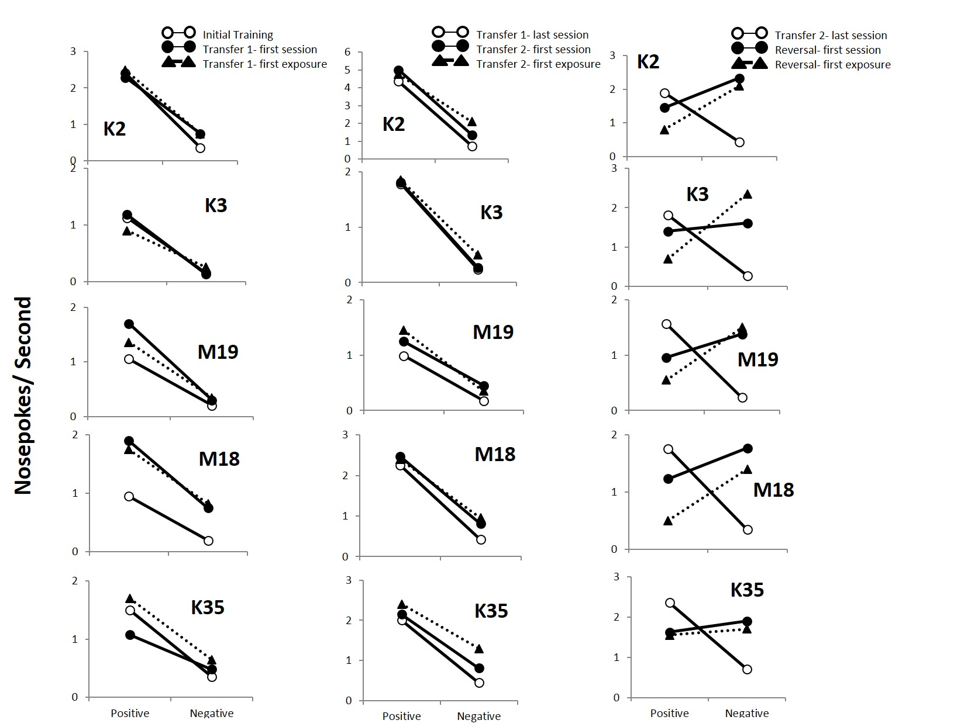

Figure 3. Response rates on positive and negative trial types for subjects trained initially on MTS. The left panel shows baseline performance on the set of odors initially trained (white circles) compared to performance on the first day of transfer phase 1 (black circles) with performance on the first exposure to the eight novel trial types depicted (black triangles) separately. The center panel shows performance on the second set of odors after criterion was met (white circles) compared to performance on the first day of transfer day 2 (black circles), with performance on the first exposure to the eight novel trial types depicted (black triangles) separately. The right panel shows the effects of reversal with the last day of performance on the initially trained contingencies (white circles) compared to performance on the first day of the reversed contingencies with a set of four novel scents (black circles), with performance on the first exposure to the eight novel trial types depicted (black triangles) separately.

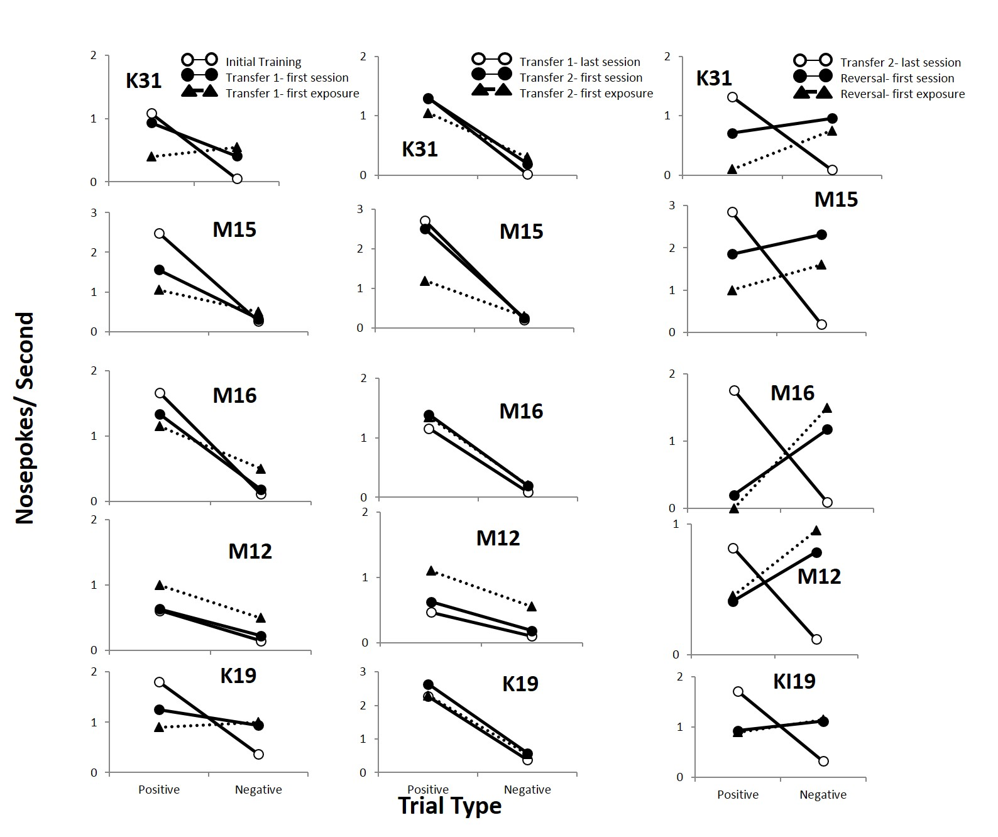

Figure 4. Response rates on positive and negative trial types for subjects trained initially on NMTS. The left panel shows baseline performance on the set of odors initially trained (white circles) compared to performance on the first day of transfer phase 1 (black circles) with performance on the first exposure to the eight novel trial types depicted (black triangles) separately. The center panel shows performance on the second set of odors after criterion was met (white circles) compared to performance on the first day of transfer day 2 (black circles), with performance on the first exposure to the eight novel trial types depicted (black triangles) separately. The right panel shows the effects of reversal with the last day of performance on the initially trained contingencies (white circles) compared to performance on the first day of the reversed contingencies with a set of four novel scents (black circles), with performance on the first exposure to the eight novel trial types depicted (black triangles) separately.